September 2019

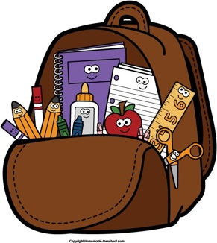
First Day of Grade One!

Just a quick note that your child’s school supplies have safely arrived!
Please know that in Gr.1A we share supplies in caddies at our seating
groups, so there is nothing to label! All “extra” items are in a cupboard
and will be given to your child as needed. Thanks!

WEDNESDAY~ Please remember the bell rings at 8:55am, and
Wednesday is 2:30 dismissal. Your child will need snacks for 10:30 recess
and 12:00 play time, plus a complete lunch for 12:30pm. We
encourage students to bring in water bottles that they keep on their
desks so they can drink and keep hydrated throughout the day.
PLEASE NOTE: No glass bottles!

All Grade Ones have gym together on Mondays and Wednesdays at the
end of the day so they will be dismissed in their gym strips those days.
Please so be sure to send your child’s Gym Bag & PE strip and gym
runners, all CLEARLY LABELLED with your child’s FIRST name/last initial!

THURSDAY- Your child’s planner will come home! Phewwff!

FRIDAY ~ Mass at 9:15- please send an item for the food bank!
Mrs. Thomson

Also – Fridays-we will have LIBRARY BOOK EXCHANGE, so be sure to
check back packs for library books!

